eBooks & Audiobooks for Cherokee High School Read on any device with Internet
eBook & Audiobook Resources | URL, Username/ Password, if needed
Abdo – Free Trial – eBooks  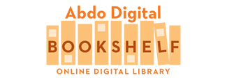 | https://abdodigital.com/?tk=840BC558E6676AB1F4C9FA29D8EC6D69  No U/P needed 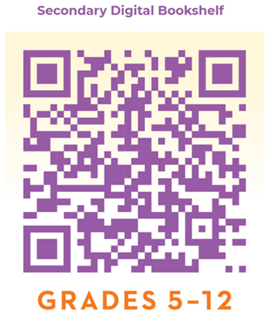
Mackin   | https://www.mackinvia.com/  Start typing Cherokee High School and pick the Canton, Ga location from the drop-down list  Username: cherokeehighschool  Password: warriors 5000 new eBooks available till 7/31/20 !
Sora   | https://soraapp.com/library/cherokeega or download the Sora app and use setup code cherokeega  You just need your CCSD network U/P.  This has lots of popular eBooks. Audiobooks are also available: use the search bar to search for “audiobooks”.
SYNC Audiobooks   | https://www.audiobooksync.com/content/uploaded/images/toolkit2020/sync_trifold_2020.pdf  Students and teachers must register their school email on the audiobooksync.com website before they can add that library to Sora.  Available for the summer, begins on April 30. Each week there are 2 new titles available. See this brochure for all the details!
Follett – eBooks   | https://search.follettsoftware.com/metasearch/ui/109552  Login to Destiny Discover with your CCSD network U/P. Scroll down to open the eBooks. Check one out to yourself. It will disappear after 2 weeks. No fines on eBooks, ever.  You can renew & check your account by clicking on the  in the upper left-hand corner, on the Destiny Discover home page.

