Go to: audiobooksync.com If you already use Sora, you’ll need to add the SYNC program’s library. Here are the steps:
- In Sora, open the menu (in the top-right corner).
- Select Add a public library.
- Search for audiobooksync and select the library from the results [2020 season starts April 30]

Get this audiobook in Sora App- Check it out, during the dates below, and it’s yours to listen to whenever you want, forever. You can listen to it on your cell phone!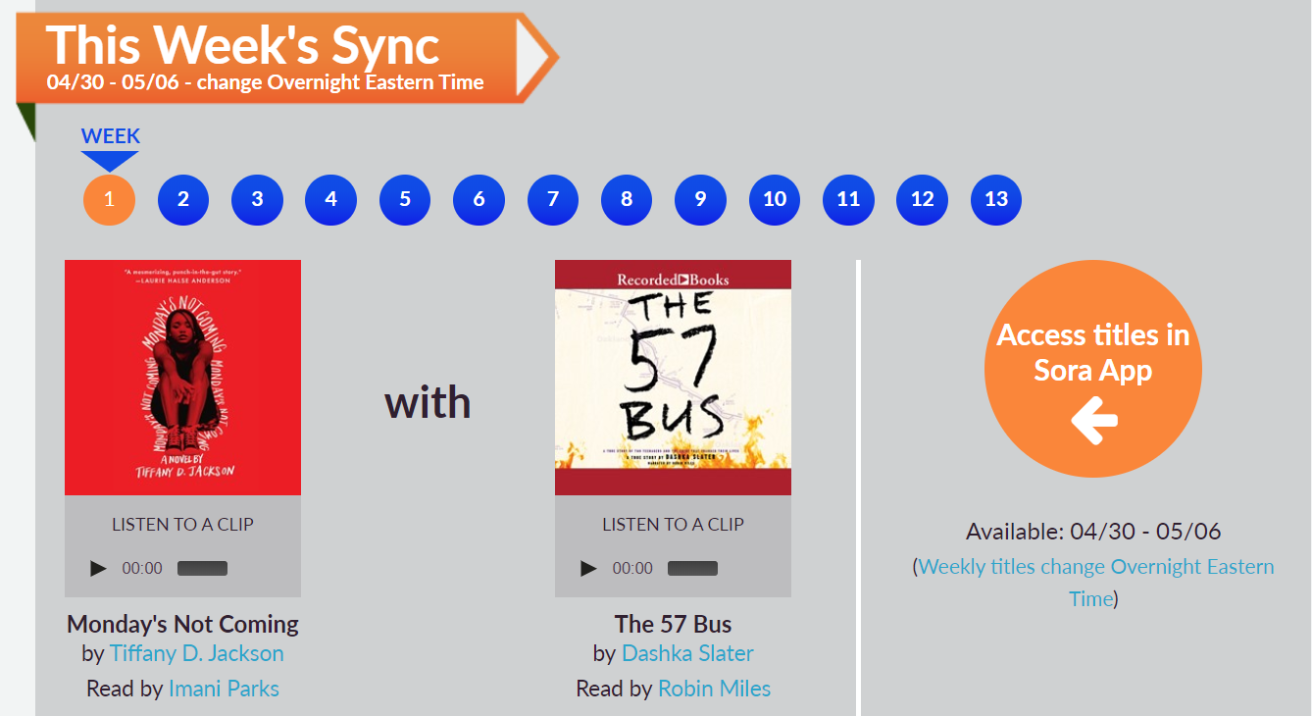
About these books

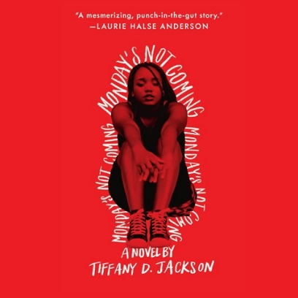
Narrator Imani Parks portrays an African American teen named Claudia who is learning-challenged. At school, Claudia has always been buoyed by her best friend, Monday Charles, but now, at the beginning of a new school year, Monday is missing, and only Claudia seems to notice. In a story that contains many time shifts, Parks' emotive narration aids the transitions that recall the closeness of the girls at home and the painful bullying they face at school.
About the mystery of one teenage girl’s disappearance and the traumatic effects of the truth.

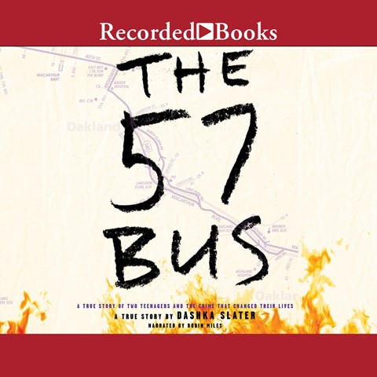
TRUE STORY of 2 Teenagers and a crime that changed their lives forever!
This riveting nonfiction book for teens about race, class, gender, crime, and punishment tells the true story of an agender teen who was set on fire by another teen while riding a bus in Oakland, California. One teenager in a skirt. One teenager with a lighter. One moment that changes both of their lives forever. If it weren't for the 57 bus, Sasha and Richard never would have met. Both were high school students from Oakland, California.

